**DESIGN OF 35 kV TRANSMISSION LINE RELAY PROTECTION**

1. **35kV Line Protection Configuration Scheme**
   1. **Introduction:**

There are several transmission line protection schemes, which can be divided into two categories: **non-unit type** and **unit type.**

Time-graded overcurrent protection, current-graded overcurrent protection, and distance protection are examples of non-unit type protection, whereas unit type protection includes pilot-wire differential protection, carrier-current protection based on phase comparison method, and so on.

Because ground faults are more common on overhead transmission lines than phase faults, and ground fault current is different in magnitude from phase fault current, separate protection systems are required. The selection of a particular scheme of protection depends upon the following factors:

1. Economic justifiability of the scheme to ensure 100% continuity of supply.
2. Types of feeders-radial or ring mains.
3. Availability of pilot wires.
4. Number of switching stations in series between supply end and the far end of the system.
5. System earthing-whether the neutral is grounded or insulated.
   1. **Basic Principles of Configuration:**

**Line Protection Influencing Factors**

The chosen protection system should include redundancy to mitigate the effects of device failure, as well as backup protection to assure dependability.

The following are high-level factors that influence line protection:

1. The importance of the line (in terms of load transfer and system stability),
2. For system stability, fault clearance time criteria must be met.
3. the length of the line
4. The line's feeding system,
5. The alignment of the line (the number of terminals, the physical construction of the line, the presence of parallel lines),
6. The loading of the line
7. The various forms of communication that are available, as well as
8. Various protection equipment failure modes.

The more specialized transmission line protection elements directly address the application's dependability and security.

Reclosing can be used to maintain a line operational in the event of a momentary malfunction, such as a lightning strike. The sensitivity of protection functions will be affected by the maximum load current level, and protection function settings may need to be adjusted under specific operating conditions. Distance elements, differential elements, and communications systems are all impacted by single-pole tripping applications. In the implementation of a protective system, the physical construction of the transmission line is also a consideration. The impedance of the line, as well as the physical reaction to short circuit circumstances and line charging current, is determined by the type of conductor, its size, and the spacing between conductors. Furthermore, the number of line terminals determines load and fault current flow, which the protection system must account for. Mutual coupling influences the ground current measured by protective relays, hence parallel lines have an impact on relaying. The presence of tapped transformers on a line, as well as reactive compensation devices like series capacitor banks or shunt reactors, has an impact on the protection scheme selected and the actual protection device settings

* 1. **TASK 1 of Relay Protection Device:**

When discussing the effectiveness of a relaying scheme, the objectives should be established. Several terminologies are used to describe the performance and dependability of relaying schemes.

**Defining Performance**

Selectivity, speed, and sensitivity are terms that define the performance of a relay element or relaying scheme. The three Ss are what they're known as. The ability of a relay element to distinguish between in-zone and out-of-zone faults is measured by its selectivity. The element's type dictates its selectivity. Branch impedance and/or duration are required for selectivity in overcurrent elements. By only responding to defects in one direction, directional overcurrent elements improve this. By being both directed and having a fixed impedance reach, distance elements improve selectivity even more. Differential elements, on the other hand, are the most selective due to the precision with which their boundaries can be matched to their protective zones.

Speed is just a measurement of how quickly a relay responds to faults, whether in-zone or not. Because speed is required to minimize voltage effects, equipment damage, increase safety, and maintain system stability, speed is a key aspect of relay performance. Inherent and purposeful time delays can have an impact on speed. Even if a relay element's delay is set to zero cycles, it will not operate instantly. It takes the element some time to make a decision, If the multiple of pickup for a certain fault situation is higher, the relay will operate faster. Intentional delays are useful for coordinating with other relays or riding through temporary situations. The levels of definite-time delay utilized for primary protection are listed in the table. Selectivity is inversely proportional to speed. More selective elements can be programmed with little or no deliberate delay, but less selective elements must rely on a delay to synchronize with remote relays.

**LEVELS OF DEFINITE-TIME DELAYS FOR PRIMARY PROTECTION**

|  |  |
| --- | --- |
| **Level** | **Delay (cycles)** |
| No intentional delay | 0 |
| Delay for block signal | 1−2 |
| Delay for fault clearing | 8−12 |
| Delay for fault clearing with breaker failure | 18−24 |

Sensitivity is a measurement of the relay's capacity to detect in-zone errors. It has an impact on how the relay functions in low-grade faults, high-resistance faults, and minimum source situations. Selectivity and sensitivity go hand in one. The more sensitive the distance and overcurrent elements are, the less selective they are, and vice versa. To create a viable relaying scheme, selectivity, speed, and sensitivity must all be balanced.

1. **Defining Reliability**

The phrases dependability and security are used to more clearly define the reliability of a relaying scheme. The capacity of a system to operate in the event of an in-zone fault is known as dependability. When there is no in-zone failure, a scheme's security is defined as its ability to not operate. They are normally antagonistic, although improved systems can improve both to enhance total reliability. When faults occur in nearby zones of protection, security is jeopardized, but dependability is only jeopardized when the fault occurs in-zone.

Approximately 94 percent of mis-operations resulted in erroneous trips, according to the North American Electric Reliability Corporation (NERC) Mis-operations Report. False trips reveal a preference for dependability, whereas failures to trip reveal a preference for security. Transmission line relaying techniques have traditionally been designed with a dependability bias to avoid trip failures or slow journeys. This is because power systems can withstand the loss of additional pieces better than problems that are uncleared. They are constructed with redundant protection mechanisms to increase dependability, and they can rely on automatic reclosing to return un-faulted elements to service. Efforts to decrease mis-operations can enhance overall reliability by minimizing false trips without sacrificing dependability by increasing failures to trip.

1. **Reducing Mis-operations**

The Protection System Mis-operations Task Force (PSMTF) issued many proposals aimed at improving protection quality by eliminating mis-operations. By properly applying and coordinating relay elements, decreasing setting errors, and increasing pilot scheme performance, false trips can be eliminated. Trip failures can be decreased by prioritizing critical firmware updates and monitoring numerical relay alarm connections to detect relay failure. The top three causes of mis-operations, as well as the circumstances in which they happened, are depicted in Figure 1. It's worth noting that the chart is dominated by false trips.

Mis-operations can occur when relay elements are not applied correctly. Coordination between elements that operate on functionally different quantities, such as distance and overcurrent elements, or between incompatible directional polarization methods, cannot be done properly. Coordination between overcurrent parts that use different measuring methodologies should be done with prudence as well.

Errors in setting can be eliminated by improving the engineering process. The quality of the settings produced can be improved with more training and peer evaluations. Standardized settings templates can also be used in standard applications to improve consistency. Finally, in the case that the topography of the system changes, previous settings should be checked to ensure that they are still appropriate.

While it is not the subject of this study, there are steps that may be taken to improve the performance of pilot schemes. Migrating to more robust communications media or better maintenance on power line carrier equipment can increase channel dependability. New technologies can also be utilized to overcome transient signal loss. When using mixed relay technologies, such as when coordinating numerical and electromechanical relays, the speed disparities must also be taken into account. Although the NERC Mis-operations Report recommends accepting varying operating speeds across different relay technologies in a communications-assisted scheme, it is vital to remember that sensitivity coordination of heterogeneous relays cannot be guaranteed completely. That is, an excessive boundary fault will cause a pilot tripping element and its corresponding distant pilot blocking element in dissimilar relays to react differently.

* 1. **Basic Requirements for Relay Protection:**

**Protective Relay:**

**A Protective Relay is a device that detects the fault and initiates the operation of the circuit breaker to isolate the defective element from the rest of the system.**

By continuously detecting electrical quantities that are different under normal and fault situations, the Protective Relay detects abnormal situations in electrical circuits. Voltage, current, frequency, and phase angle are all electrical quantities that can alter when there is a malfunction. The faults transmit their presence, nature, and location to the protective relay by changing one or more of these values. The relay closes the trip circuit of the breaker after detecting the malfunction. As a result, the breaker is opened, and the problematic circuit is disconnected.

[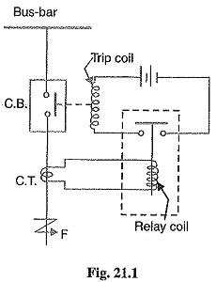](https://www.eeeguide.com/wp-content/uploads/2018/06/Protective-Relay.jpg)

**Figure 1: Protective Relay**

A typical relay circuit is shown. This diagram shows one phase of 3-phase system for simplicity. The relay circuit connections can be divided into three parts viz.

* **First part is the primary winding of a current transformer (CT.) which is connected in series with the line to be protected.**
* **Second part consists of secondary winding of C.T. and Cu. the relay operating coil.**
* **Third part is the tripping circuit which may be either AC & DC. It consists of a source of supply, the trip coil of the circuit breaker and the relay stationary contacts.**

When a short circuit occurs on the transmission line at point F, the current flowing through the line explodes. This causes a large current to travel through the relay coil, forcing the relay to close its contacts and activate. This shuts the circuit breaker's trip circuit, opening the breaker and isolating the malfunctioning component from the rest of the system. As a result, the relay assures the circuit equipment's safety from harm as well as the healthy portion of the system's normal operation.

### **Fundamental Requirements of Protective Relay:**

The primary function of a Protective Relay is to cause the immediate removal from service of any element of the power system that begins to perform abnormally or interferes with the system's effective operation. The following features should be present in a protective relay system in order for it to perform this duty satisfactorily:

1. **Selectivity**
2. **Speed**
3. **Sensitivity**
4. **Reliability**
5. **Simplicity**
6. **Economy**
7. **Selectivity:**

**It is the ability of the protective system to select correctly that part of the system in trouble and disconnect the faulty part without disturbing the rest of the system.**

A well-designed and efficient relay system should be selective, in the sense that it should be able to recognize the location of the fault and cause the circuit breakers nearest to the fault to open with minimal or no system damage. A single line diagram of a section of a typical power system can be used to demonstrate this. Circuit breakers are visible in the connections to each power system part, allowing only the defective component of the system to be disconnected. As a result, if a fault develops at bus-bars on the last zone, only the breakers 10, 11, 12, and 13 should open. In fact, if any additional breaker is opened to clear the problem, a larger portion of the system will be disconnected.

[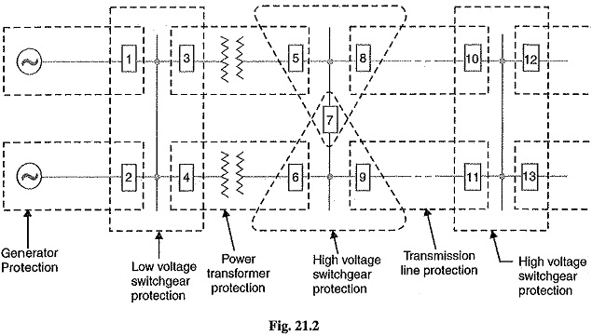](https://www.eeeguide.com/wp-content/uploads/2018/06/Protective-Relay-1.jpg)

**Figure 2: Zones of Relay**

It is common practice to partition the entire system into numerous protective zones in order to provide selectivity to the system. Only the circuit breakers in that zone will be opened when a fault occurs in that zone. Only the damaged circuit or apparatus will be isolated, leaving the healthy circuits unaffected.

The system can be divided into the following protection zones:

* **Generators**
* **Low-tension switchgear**
* **Transformers**
* **High-tension switchgear**
* **Transmission lines**

There is some overlap between the nearby protection zones, as can be seen. When two neighbouring zones overlap and a failure occurs, more breakers will be opened than are required to disconnect the damaged part. However, if there was no overlap, a failure in the zone-to-zone region would not occur in either region, and so no breaker would be opened. As a result, a specific amount of overlap between adjacent zones is provided.

1. **Speed:**

The relay system should disconnect the faulty section as fast as possible for the following reasons:

* **Electrical apparatus may be damaged if they are made to carry the fault currents for a long time.**
* **A failure on the system leads to a great reduction in the system voltage. If the faulty section is not disconnected quickly, then the low voltage created by the fault may shut down consumers motors and the generators on the system may become unstable.**
* **The high speed relay system decreases the possibility of development of one type of fault into the other more severe type.**

1. **Sensitivity:**

It is the ability of the relay system to operate with low value of actuating quantity.

The volt-amperes input to the coil of the relay required to cause it to operate determines its sensitivity. The more sensitive the relay is, the less the volt-ampere input required to get it to operate. As a result, a 1 VA relay has a higher sensitivity than a 3 VA relay. It is desirable that the relay system be sensitive enough to work with low volt-ampere input values.

1. **Reliability:**

It refers to the Protective Relay system's ability to work under predetermined conditions. The protection would be rendered entirely worthless and could even become a liability if it lacked reliability.

1. **Simplicity:**

The relaying system should be simple in order to be maintained easily. Simplicity and reliability are inextricably linked. The more straightforward the protection method, the more reliable it will be.

1. **Economy:**

The cost component is the most significant consideration when selecting a protection plan. When using an ideal plan of protection is economically justifiable, a compromise solution must be used. In general, protective equipment should not cost more than 5% of the entire cost. When the apparatus to be protected is critical (e.g., a generator or a main transmission line), however, cost considerations are often put aside in favour of reliability.

* 1. **Main Protection & Backup Protection**

## **Primary Protection**

The main protection, also known as primary protection, is the initial line of defense against a fault that occurs inside the circuit section or element it protects. It acts quickly and selectively to remove the fault inside the circuit section or element it protects. Each section of an electrical installation has its own main protection.

## **Backup Protection**

When the main protection fails or is cut out for repairs, the backup protection supplies a backup to the main protection. The backup protection is required for the electrical system to function properly. The backup protection is the system's second line of defense, isolating the defective component of the system if the first protection fails. The primary protection circuit may fail due to a failure of the DC supply circuit, current or voltage supply to the relay circuit, relay protective circuit, or circuit breaker.

**The backup protection might be installed on the same circuit breaker that the main protection would typically open, or on a different circuit breaker. When the main protection of a neighbouring circuit is unable to backup the main protection of the given circuit, the backup protection is applied. For simplicity, backup protection is sometimes set to a low sensitivity and operated over a small backup zone.**

**Example:**

Consider the remote backup protection is provided by a small time graded relay, as shown in the figure below. Let F be the fault occur on relay R4. The relay R4 operates the circuit breaker at D and isolate the faulty section. Now if the circuit breaker D fails to operate, the faulty section would be isolated by the operation of the relay R3 at C.

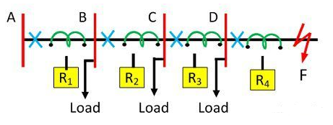

**Figure 3: Backup Protection**

The use of the backup protection depends on the economics and technical consideration. The backup protection usually for the economic reason not so fast as the main protection.

1. **The failure Analysis of 35kV line**
   1. **Analysis of Common Failures:**

**FACTORS OF A TRANSMISSION LINE FAULT**

The transmission lines are mostly exposed in the air to the harsh environment of nature which produces various types of failures. Thundering, rain, lightning phenomena, flashover, winter ice, fog, fog stick on the insulator, and pollution cause poor contact insulators and transmitters.

## **Typhoon factors**

Strong winds blow the transmission lines, which are generally located in difficult terrain and surrounded by green forest blocks. This failure of line fault-prone form of the regular power supply of the power system hazards is fairly considerable, and in the case of failure, induced by wind partial trip. The combination of a strong wind source with a narrow voltage pole spread causes the pole to collapse, resulting in a power transmission interruption. As a result, a power system fault occurs.

## **Lightning factors**

Lightning strikes frequently in the River Delta region in the spring and summer. Thunder and lightning produce transmission line failure, resulting in a substation accident trip. The cause of the accident is mostly due to lightning over-voltage resulting in a short circuit, which caused the lines to fail.

## **Overlying ice factors**

Although transmission line icing is caused by a line break accident that only occurs in the winter, the consequences of the accident show that in the event of ice cover, the intensity of labour, repair, and maintenance takes significantly longer than in other regions. Furthermore, the maintenance personnel has a difficult time doing repairs and upkeep. Ice cover forms as a result of cold temperature, air, and humidity, and as ice cover forms, the overall weight of the transmission line increases, resulting in line breakdown.

## **Filthy factors**

Pollution is a serious problem. Transmission line flashover destroys the insulation coating. It will result in flashover situations as a result of such accidents, primarily because the insulator surface is not scheduled to dust, especially on windy and rainy days, where dust build on the insulators and line would generate unclean ionization. There is a flashover.

## **External damage factor**

Various circumstances, such as gale days, damaged trees, vast tracts of trees fallen on the road, increased the burden on the line to be broken, theft of low voltage lines, and collisions of autos with poles, can cause exterior damage to transmission lines. The occurrence of such accidents is one of the factors that led to the transmission lines being faulty.

# **PROTECTION STRATEGIES**

Transmission lines must be protected in order for the power system to run smoothly and to prevent the danger of damage to regular operating components. The following paragraphs outline some of the measures for preventing the lines:

**Improve the quality of the electrical design:**

The security will be increased by improving the quality of the electrical design. The operation of various electrical appliances is designed without regard for the installation's surroundings. Transmission line components such as towers, conductors, insulators, and auxiliary fittings are designed the same throughout the transmission of the power system, regardless of environmental circumstances. For designers who merely mechanically duplicate, duplicate the normal design and design specifications, the calculation and selection of Ray devices is critical. As previously said, lightning factor causes a fault, which can be protected by using a specific design. The designer, in accordance with the local environment, takes appropriate lightning protection measures, replicating the design specification, resulting in lightning factor protection. Later, when surge arresters were installed on towers, the accident occurred infrequently at the same time. Power lines must also be designed in a fair manner in order to properly perform their functions. The transmission line design process necessitates meticulous calculations, site surveys, and line path selection of the topography and line path. These precautions may help to prevent a variety of incidents and ensure the transmission line's regular operation.

## **Lightning protection measures**

The transmission line's lightning protection and grounding operations are unquestionably more significant, and the lightning conductor transmission line lightning over-voltage protection is the most often employed anti-Ray device. However, in order to meet the goal of lightning protection, we can minimize the tower grounding resistance.

## **Tower location and the correct choice of the rod**

Initially, the climatic conditions and terrain should be thoroughly examined; try to avoid erecting the tower in difficult terrain or in a remote place; and improve the mechanical strength of the tower by using a steel bar or a thicker type of concrete pole cross arm. In ice-prone areas, a modified structure for the cross arm put on the pole is recommended. The insulator's structure should match the coating's hydrophobic characteristics.

## **Prevention of pollution flashover**

Pollution flashover results in a lot of incidents, and the effect causes a fault to develop. The prevention of lines with pollution flashover is to improve the power system for the safe use of electricity distribution, continuing the important work of the electricity by increasing the creep age distance and the use of synthetic insulators, or the use of anti-pollution flashover coating, thereby limiting the occurrence of leakage cu.

## **External damage prevention**

Strong winds cause trees to fall across the transmission line, causing external damage. Furthermore, there is an increase in the number of thefts and road accidents. As a result, it should be optimized the electrical design and power transmission lines so as not to be too close to woods, to take full account of the "hazard" brought to the tree growth rate and the road to maintain the proper distance, and in accordance with the specific location of the tower, additional protection pier, and finally painted with eye-catching protective signs. For, external damage to the transmission line fault analysis, may take the following steps to protect the transmission lines:

* Increase the protection of power facilities and efforts to do the publicity and education work of the electricity users and the establishment of a strict line inspection system.
* To constantly improve the electricity regulations to strengthen the power of law enforcement efforts. Co- organized with the relevant departments of electrical safety a speech contest and knowledge contests and other activities to promote electrical safety regulations, so that we fully understand the dangers of electricity, so that those desperate daunting, quit.
* To develop practical methods and measures, and implementation of practical work.
* Training and to build a tough, good tough fight, a professional technical team is to protect the transmission lines necessary to ensure safety.

# **RECOMMENDATIONS THE PROBLEMS MENTIONED IN THE PAPER CAN BE PREVENTED BY ADOPTING THE FOLLOWING METHODS:**

## **Transmission line structure**

Instead of using a lattice or H-type transmission structure, a tabular structure should be used. Tabular transmission structures are preferred over other structures because they may be erected in 30-foot sections with a wide range of diameter sizes and material thicknesses. A hot dip galvanized coating or metallic paint especially developed for excellent weathering over a longer length of time can be applied to tabular structures.

## **Type of conductor to be used**

Aluminum conductors reinforced with steel (ACSR) were used in the transmission lines but they can be replaced by the modern conductor that offers reduced thermal sag is known as ACCC ("Aluminum Conductor Composite Core"). In lieu of steel core strands that are often used to increase overall conductor strength, the ACCC conductor uses a carbon and glass fiber core that offers a coefficient of thermal expansion about 1/10 of that of steel. While the composite core is nonconductive, it is substantially lighter and stronger than steel. Its lighter weight allows the incorporation of 28% more aluminum (using compact trapezoidal shaped strands) without any diameter or weight penalty. The added aluminum content helps reduce line losses by 25 to 40% compared to other conductors of the same diameter and weight, depending upon electrical current. The ACCC conductor's reduced thermal sag allows it to carry up to twice the current compared to AAC ("All Aluminum Conductor") or ACSR ("Aluminum Conductor Steel Reinforced").

## **Distance and shape of the poles**

The transmission line system can be given extra strength by reducing the distance between the poles. When a triangle-shaped cross arm is used in an ice-prone environment, the accumulation of ice on the pole is reduced, but the overall weight of the transmission pole is not increased. The strength of the power distribution system can be increased by thickening the cross arm and employing a tabular structure.

## **Installing lightning arrester**

A lightning arrester is installed when wires enter a structure to protect transmission lines from damage and ensure the safety of people nearby. Surge protectors, also known as lightning arresters, are devices that connect each electrical conductor in a power system to the Earth. They prevent typical power or signal currents from flowing to ground, but they allow a conduit for high-voltage lightning current to travel through, bypassing the connected equipment. Their goal is to keep the voltage from becoming too high when a communications or power line is struck by lightning or is about to be struck by lightning.

## **Corrosion evaluation methods for power transmission lines**

Individual component designs for power transmission have altered, but the materials used in construction have stayed mostly unchanged. Steel and cast iron (raw, coated, or galvanised), aluminium alloys, and copper alloys are used in this way. Various treatments, coatings, and inhibitors are used to improve the corrosion resistance of these materials, extending the life of the transmission lines.

* 1. **The transmission line design process**

Recent advancements in surveying technology have led the industry to reconsider the station-elevation-offset forms utilised by designers for transmission line profile modelling. This surveying method uses a three-dimensional geographic information system (GIS) to depict the data. Data is typically collected in electronic format, and transmission line software can intelligently read data in any format. Total Station, Geographical Positioning System (GPS), Photogrammetric, electronic topographical maps (USGS), and scanned or digitized existing profile drawings have all been employed to develop quick and relatively accurate land models for transmission lines. This can be efficiently use for the detection of the fault in the transmission line throughout the stretch of the line.

* 1. **Using Underground transmission lines**

Underground cables take up less space, have less visibility, and are less influenced by adverse weather than above wires. Insulated cable and excavation, on the other hand, are substantially more expensive than overhead construction. Underground lines are constrained by their thermal capacity, allowing for fewer overloads and re-ratings than above lines. As a result, we can use subterranean transmission lines in regions where overhead transmission lines are not suitable due to environmental conditions.

* 1. **Configuration of 35kV line relay Protection:**

|  |  |  |  |  |
| --- | --- | --- | --- | --- |
| **Type of Protection** | **ANSI Codes** | **Causes** | **Effect** | **Protection Scheme** |
| **Distance Protection (Phase & Ground)** | 21 | Reduction in overall line impedance (V/I) due to fault conditions. | Fault current can overheat the transmission line and can cause damage to the conductor. | Distance protection relay serves as a primary protection for transmission lines. It keeps track of the line impedance and sends trip signal to the breaker if the line impedance changes (due to fault) |
| **Over Voltage Protection** | 59 | Lightning, switching, temporary over voltage | Give rise to transient over-voltages which can damage the insulation. | Surge Arrestors/ Over-voltage relay with preset voltage limits defined in settings |
| **Power Swing Blocking** | 68 | Line switching, generator disconnection, addition/loss of load | Loss of synchronism between a generator and the rest of the system as seen by the measured voltages, phase sequences, phase angles. Frequencies resulting in swing in power flow. | A blocking relay provides this protection and has the same type of characteristic as a distance relay |
| **Over-Current Protection (Phase & Ground)** | 50/51 | Due to short circuit, single-phase to ground or phase to phase faults. Can occur due to tree limbs falling on lines, etc. | Gives rise to heavy current that flows through the winding conductor and causing overheating of the conductor which will deteriorate it | An over current protection relay which also serves as a back-up for distance protection is used. In case the distance protection (primary protection) malfunctions, over-current protection will send trip commands |
| **Earth Fault Protection** | 50N/51N | Direct connection to ground of one or more places. | Gives rise to higher voltages on other lines and stresses the insulation of cables and other equipment connected to the system | Over-current relay that continuously monitors the current through the neutral and sends trip signals to the breaker upon fault detection |

1. **35kV Line Protection Scheme Order**
   1. **Basic Configuration and specifications:**

**Overload Protection of Transmission Lines:**

Because it is the simplest method of guarding a line, it is extensively employed. The fact that the fault current in the event of a short circuit will rise to a value several times that of the maximum load current justifies the use of overload or overcurrent protection. To avoid the likelihood of mal-operation under normal operating conditions, the ratio of minimal fault current to maximum load current is used as a criterion. This type of security can only be used on simple systems. Overcurrent protection is provided at the line's supply end.

The protection mechanism against feeder overloading is depicted in the diagram. Three CTs are installed on the feeder, one on each phase, and are connected across the three relay coils. In the event of an overload, the relays' solenoid plunger mechanism closes the trip coil circuit, which activates the circuit breaker, disconnecting the protected feeder. When the system is changed, the relays need to be readjusted or possibly replaced. The operation times are usually quite long.

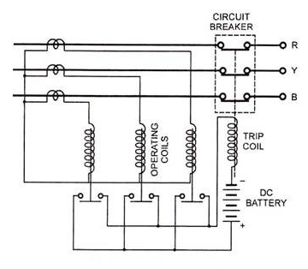

**Figure 4: Overload Protection**

The alternative method for overload or overcurrent protection is the well-known Z-connection which requires only two relays for the protection of a 3-phase circuit.

**Overcurrent and Earth-Fault Protection of Transmission Lines:**

In most cases, a system of two or three overcurrent relays is used to protect against phase-to-phase faults, with a separate overcurrent relay used to defend against single line-to-ground failures. Separate earth fault relays are often preferred over phase relays because they can be tuned to provide faster and more sensitive protection for single line-to-ground problems.

Earth fault current depends on the type of neutral earthing, i.e., whether solidly earthed, insulated or earthed through some resistance or reactance. Where no neutral point is available, grounding transformer is employed.

Whatever the type of neutral earthing be employed, the earth-fault current will be small as compared to phase- fault currents in magnitude. The relay thus connected for earth fault protection is different from the ones provided for phase-to-phase faults.

In case of resistance earthed or solidly earthed systems, the overcurrent element connected in residual circuit of CTs is preferred. The setting of earth-fault relays may be made less than rated full-load current of the line. The practice followed is to apply relays having a setting range of 10 to 40%. A setting of 20% on 300/5 A CT means the relay operates for primary earth-fault current of 300/5 x 20/100 = 12 A.

In the above protection scheme two IDMT type overcurrent relays are connected in two phases through CTs and one earth-fault relay. In case of phase-to-phase faults or overload the IDMT relays trip the circuit breaker. Under healthy conditions, the sum of all the three currents of CTs is zero and the earth-fault relay remains inoperative. As soon as phase-to-ground fault occurs unbalancing in currents causes the earth-fault relay to operate, which in turn trips the circuit breaker.

The earth-fault elements are with inverse characteristics and time-grading is preferred for earth fault protection of radial feeders.

This scheme is employed for 11 kV and 33 kV systems as main protection and is used as a backup protection for transformers and transmission lines in EHV systems.

**Current-Graded Protection of Transmission Lines:**

An alternative to time grading or in addition to time grading current grading protection can be applied when the impedance between two substations is sufficient. It is based on the fact that the short-circuit current along the length of the protected circuit decreases with the increase in distance between the supply end and the fault point. If the relays are set to operate at a progressively higher current towards the supply end then the drawback of long time delays occurring in graded time lag system can be partially overcome. This is known as current grading. Current-graded systems normally employ high-speed high-set overcurrent relays.

A simple current-graded protection scheme applied to a radial feeder is shown in Fig. 5.8. It consists of high-set overcurrent relays at A, B and C with settings such that relay at A would operate for faults between A and B, the relay at B for faults between B and C and the relay at C for faults beyond C. The current setting diminishes progressively from the supply end to the remote end of the line.

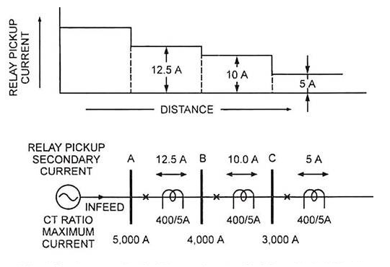

**Figure 5: Current-Graded Protection Applied to a Radial Feeder**

**In practice, however, this protection scheme poses some difficulties which are given below:**

* 1. The relay cannot differentiate between faults which are very close to, but are on each side of B i.e., if a fault is very near to station B in section BC, the relay at A may feel that it is in section AB because there may be very little difference in the fault currents and the relays do not discriminate between the fault in the next section and the end of first section.

**This is because:**

**(i)** The difference in the fault currents would be extremely small,

**(ii)** The magnitude of fault currents cannot be accurately determined, and

**(iii)** The accuracy of the relays under transient conditions is likely to be different.

Hence for discrimination the relays are set to protect only part of the line, usually 80%. For this reason current grading alone cannot be employed and this protection system should be supplemented by time-graded inverse definite minimum time (IDMT) relay system.

**2.** The fault currents are different for different types of faults and so a certain difficulty is experienced in relay setting.

**3.** For ring mains, parallel feeders, interconnected systems, where power can flow to the fault from either direction, a system without directional control is not suited.

#### Differential Pilot-Wire Protection of Transmission Lines:

The term “pilot” means that between the ends of a transmission line there is an interconnecting channel of some sort over which information can be conveyed. Three different types of such a channel are presently in use, and they are called “wire pilot”, “carrier-current pilot” and “microwave pilot”. A wire pilot consists generally of a two-wire circuit of the telephone-line type, either open wire or cable. A wire pilot is generally economical for distances up to 8 or 15 km, beyond which a carrier-current pilot usually becomes more economical. Microwave pilots are employed when the number of services requiring pilot channels exceeds the technical or economic capabilities of carrier current.

The differential pilot-wire protection is most satisfactory and is widely employed on account of the advantages such as simplicity, flexibility, a high stability ratio, rapid fault clearance (a time varying between 0.1 and 0.5 second according to the “break time” of the circuit breaker).

The differential pilot-wire protection is based on the idea that under normal operating conditions, the currents compared at either end of the line or feeder using pilot wires should be the same, and that the equality is only lost when there is a fault between the two ends. The method is quite similar to that used to protect alternators and transformers, with the only difference being the length of the pilot wires.

#### Current Balance Differential Protection of Transmission Lines:

Biased differential protection due to McColl is an example of current balance differential protection.

For understanding its principle let us first consider the protection of Single-Phase feeders. The scheme is illustrated in Fig. The current transformers CT1, and CT2 are mounted on the two ends of the protected line. The secondaries of the two CTs are connected through the restraining coils R1 and R2 and pilot wires P1and P2. The operating coils of the relays are also connected across the secondaries of the CTs through diverting resistances DR1 and DR2 as illustrated in Fig.

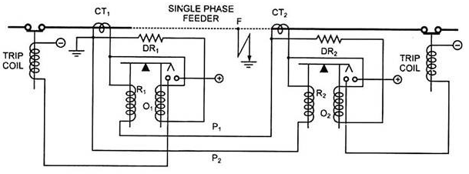

**Figure 6: McColl Circulating Current Protection for Single Phase System**

Each of these two diverting resistances is equal to pilot wire resistance which will cause same current to flow through the operating coils O1 and O2. For equal number of turns on restraining coil and operating coil equal pull will be exerted on the sides of the beam relay. However, mechanical biasing can also be provided by moving the fulcrum towards the operating coil and such an arrangement can allow 10 to 12 per cent greater current to flow in the operating coil before it can close contacts.

For an earth fault at point F, the current in CT1 will exceed that in CT2. The secondary current of CT1 will be flowing in two parallel paths—one path will be through diverting resistance DR1 and operating coil O1 and the second path will be through restraining coil R1, pilot-wire P1, diverting resistance DR2, operating coil O2, restraining coil R2 and pilot-wire P2. Obviously, the resistance of second path (consists of 3 coils, 2 pilot-wires and one diverting resistance) is 3 times that of first path. Thus three- fourth of the total current will flow through the operation coil O1 and one-fourth through the restraining coil R1. If the current flowing through the operating coil O1 exceeds the relay setting, the feeder will be disconnected from the supply end.

Figure. shows the application of biased differential protection to a 3-phase feeder. The CT sets CT1 and CT2 are connected in delta formation because the star-connection would require four-pilot wires, the fourth pilot-wire being connected between two-star points. The diverting resistances DR1 and DR2need only be one half of the resistance of one pilot-wire, as the return pilot utilized for the fault current will also include a resistor equal to one half of this pilot resistance.

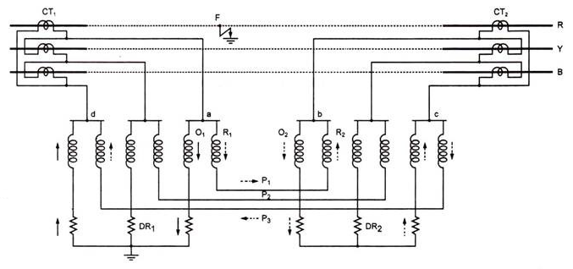

**Figure 7: McColl Circulating Current Protection for Three Phase System**

Let there be a fault in the R-phase at point F. The excess current in the secondary of CT1 will flow to junction a where it will divide into two parallel paths—one path through operating coil O1 and the diverting resistance DR1 shown by solid arrows, and another path will be through restraining coil R1, pilot wire P1, restraining coil R2, junction b, operating coil O2, diverting resistance DR2, junction c and then to junction d through pilot wire P3, as shown by dotted arrows.

**The advantages of this protective scheme are given below:**

**1.** The relay operating current increases automatically with the increase of through fault current which eliminates the possibility of malfunctioning of the relay.

**2.** As the pilot capacitive current flows through the restraining coil instead of operating coil, this current adds to restraint.

#### Merz-Price Voltage Balance System of Transmission Lines:

Probably the best known of the differential systems is the Merz-Price system, which, as applied to feeder protection, utilizes the principle of voltage balance. In 3-phase systems each conductor has its own pair of current transformers and relays. The secondaries of current transformers are connected in series by means of pilot wires. In normal conditions i.e., when there is no fault on the feeder, equal currents flow at the two different ends, so induced voltages in the secondaries of current transformers are equal.

As the secondaries are connected in opposition their secondary emfs are equalized resulting into no circulating current in the relays. But whenever fault occurs, currents differ at two ends, so induced emfs in the secondaries of current transformers will differ and circulating current will flow through the pilot wires and relays and the faulty feeder will be isolated.

It will be clear that the current transformers are critical feature of this system, since they have to be balanced exactly, not only initially but permanently. In order, that the induced voltage shall be proportional to line current, it is essential that the magnetic circuit shall not reach saturation, and this is accomplished by employing distributed air gap current transformers.

To secure initial matching, the CTs are balanced against a standard, and to ensure that there shall be no change of characteristics in service they are enclosed within a magnetic shield which prevents neighbouring iron affecting the distribution of flux. The pilot wires are usually in the form of a 3-core cable of size 7/0.73 mm.

**This system has the following advantages and disadvantages:**

**Advantages:**

**(i)** This system is independent of operating voltage and fault power factor.

**(ii)** This system can be employed for protection of both, ring mains as well as parallel feeders.

**(iii)** This system provides instantaneous protection for ground faults, so the possibility of these faults involving other phases is reduced.

**(iv)** This system provides instantaneous relaying thereby reducing the amount of damage to overhead conductors resulting from arcing faults.

**Disadvantages:**

**(i)** The trouble due to capacitance currents in the pilot circuit arises from the fact that, under through-fault conditions, voltages of the order of 1,000 volts or more are impressed on this circuit so that capacitance currents are comparatively heavy, and false operation may take place.

However, this drawback can be overcome by the introduction of the Beard-Hunter compensated pilot cable in which means are provided for diverting the capacitance currents from the relays. This action is achieved by surrounding each pilot wire with an insulated metallic screen or sheath which is divided at the centre of its length so as to form two conductors of equal lengths. When a heavy overload comes on, a high voltage is induced in the current transformer secondaries, but the resulting capacitance current, instead of flowing in the relays, flows in the local circuit formed by the sheath, current transformer and pilot wire.

**(ii)**This system does not provide backup protection or overload protection.

**(iii)**Difficulties are experienced in balancing the secondaries of the two current transformers and that is why this system cannot be used beyond 33 kV.

**(iv)**The system will not operate in case a break in the pilot wire occurs.

**(v)**This system is very expensive owing to the greater length of pilot wires required.

**(vi)** There is no time delay.

#### Translay Protection System:

The name “Translay” is evolved from the fact that the relay embodies a transformer feature. This system can be employed for protection of single phase or 3-phase feeders, transformer feeders, feeders with a tee-off and parallel feeders against both earth and phase faults. This system is based on the established principle of the current entering at one end of the feeder being equal at any instant to that leaving at the other end. A simple form of Translay protection for a single-phase feeder is shown in Fig. Under healthy conditions the line current transformers CT1 and CT2, at opposite ends of the feeder carry equal currents and, therefore, the coils 1 and 1′ connected to them induce equal emfs in the windings 2 and 2′ respectively.

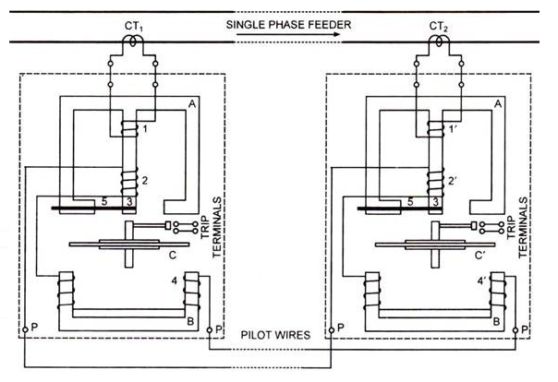

**Figure 8: Protection System for Single Phase Feeders**

Since the windings 2 and 2′ are connected in opposition by means of pilot wires with the operating coils 4 and 4′ in series with them so no forward torque is exerted on the disc. When a fault occurs, the current through one CT is greater than that through the other so a small current circulates through the operating coils and pilot wires and when it attains the preset value the relay is caused to close the tripping circuit and thus disconnect the faulty feeder. The Translay relay employed is quite similar in construction to an overcurrent induction type relay.

The Translay system, employed for a 3-phase circuit has a single-element relay at each end of the feeder which protects against both faults between phases and faults to earth. The connections (omitting trip circuits for sake of clarity) are shown in Fig.

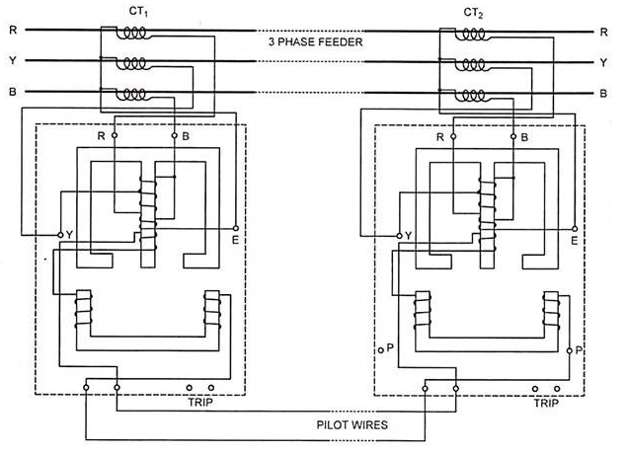

**Figure 9: Translay protection system for 3-phase feeders**

The upper magnetic circuit has three windings, two primaries and a secondary. The upper and smaller primary is a phase-to-phase fault winding and is connected across the red and blue protective current transformer while its mid-point is connected to the yellow. The lower and larger primary winding acts as a leakage winding, and is connected between the blue protective current transformer and the star point of the current transformers.

The secondary winding provided on the upper magnetic circuit acts like the opposed-voltage transformer in the Merz-Price system and is connected in opposition to a similar winding by means of two pilot wires, at the other end of the feeder. The secondary windings provided on the lower magnetic circuit are connected in series with the pilot wires. The rotating disc is composed of two sectors. Under normal operating conditions no current flows through the pilot wires as the opposing voltages are equal. On the occurrence of fault, the voltages in the windings differ and so a current flows through the lower elements and pilot wires.

A forward torque is thus exerted on the disc due to interaction of flux produced in the lower magnetic elements with the leakage flux of the upper magnetic elements. The phase relation required is achieved as in an energy meter. The capacitance currents lead the voltages and tend to rotate the disc in the opposite direction because of a closed copper ring near the end of the projecting limb of the upper magnetic circuit. Thus the main disadvantages of Merz-Price system have been avoided.

The Translay relay can be biased by an unsymmetrical phase adjustment, which provides a backward torque when the flux in the upper element is large.

**This system has got following advantages over Merz-Price system:**

(i) The capacitive currents do not affect the operation of the relays.

(ii) Only two pilot wires are required.

(iii) The current transformers of normal designs i.e., with air gap can be employed.

(iv) The pilot resistance does not affect the operation as major part of energy required to operate the relay is obtained from current transformer.

(v) The closed copper loop provided in the relay prevents the relay from operating for through fault current.

#### Split-Conductor Protection of Feeders:

This approach is another way to get the advantages of a balanced protection system without having to use pilot wires. The operation is based on the notion that when two conductors of similar length and impedance are linked in parallel, they will share the load equally, as long as the system's insulation is sound. When a defect develops on one conductor, that conductor will carry more current than the others, and this current imbalance is used to run a relay and isolate the damaged line.

Each phase of the line is separated into two pieces with equal impedances in this protection scheme. The two portions are separated by a thin layer of insulation. A single-turn current transformer is fitted at each end of the split conductor in this design. A secondary winding is wound all the way around the periphery of the current transformers, which are made up of laminated iron rings.

Under healthy conditions the current flowing along the two splits is equal and since these are threaded through the current transformers CT1 and CT2 in the opposite directions hence the voltage across the terminals of the evenly spread secondary winding is zero. In fault conditions one of the split takes more current than the other, thereby giving rise to an unbalance of the primary side of the current transformers. Due to unbalancing of currents on the primary side of current transformers resultant flux will be set up in the core of the one of the current transformers and so the current will be induced in the evenly spread secondary and the relay coil R will be energized. The relay contacts will be closed and the trip coil will trip the circuit breaker and isolate the fault.

The splits should be carried into the circuit breakers on both sides of the feeder, so that the breakers can open the splits. As a result of the splits not being transported into the circuit breakers, a fault arises at the receiving end of a lengthy line. The differential current transformer's impedance at this end may be insufficient to induce unbalance between the currents carried by each split conductor under these conditions. As a result, the circuit breakers will not clear the fault since the relay will not activate.

After the sending end circuit breaker has tripped, the fault current is confined to the faulty split when the splits are carried into the circuit breakers. Although the sending end circuit breaker trips in the first scenario, the fault current is not contained to the faulty split and instead divides nearly evenly between the two solidly linked splits, preventing the receiving end circuit breaker from tripping. The fault current is confined to the faulty split in the latter scenario, and the receiving end circuit breaker is opened.

The downside of this technique is that it requires us to use a special type of cable with lower voltage restrictions. In the case of overhead feeders, a duplicate set of conductors, insulators, and other components must be used for each phase. This approach cannot safeguard lines with step-up or step-down transformers or voltage regulators.

#### Microwave Channel Protection of Transmission Lines:

Microwave channels are utilized for all types of protections that would otherwise rely on a power line carrier or a pilot wire. The transmission is often by line of sight, which must account for the curvature of the globe as well as the topology of the route covered by the transmission. The maximum length of the simplest microwave channel is thus limited to around 40 to 60 kilometres.

It connects the relaying equipment installed at the terminals of the protected line using an ultra-high frequency (450 MHz to 10,000 MHz) transmitter-receiver system. In this situation, the communication channel is space, hence the line does not require any additional equipment. The transmitters and receivers are controlled in the same way as carrier-current transmitters and receivers are handled.

The signals are conveyed through line of light antenna equipment with radio links (microwave pilots). These are the most expensive, but they give quick and consistent service. Radio links are utilized in the United States for communication, remote control, and security.

#### Distance or Impedance Protection of Transmission Lines:

The distance protection provides discrimination protection without making use of pilot wires. Distance protection is widely employed for protection of high voltage ac transmission lines because of its inherent advantages.

**[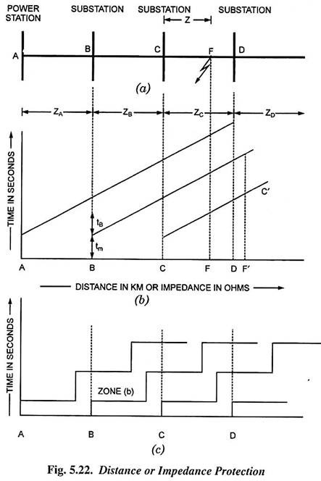](https://www.engineeringenotes.com/wp-content/uploads/2017/12/clip_image030-5.jpg)**

**Figure 10: Distance or impedance protection**

Fig. shows the simplest system consisting of feeders in series such that the power can flow only from left to right. The relays at A, B, C and D are set to operate with impedances less than ZA, ZB, ZC and ZD respectively. For a short-circuit fault at point F between substations C and D, the fault loop impedances at power station A and substations B and C are (ZA + ZB + Z), (ZB + Z), and Z respectively. It is obvious that only relay at substation C will operate. Similarly, for short-circuit faults between substations B and C, and power station and substation B only relays at substation B and power station A respectively will operate.

A system with instantaneous impedance relays, set to act on impedances less than or equal to the impedance of a section, as illustrated in Fig. (a), would be difficult to adjust; a fault near the junction of two sections is likely to cause the operation of two relays. Furthermore, if a fault of finite resistance occurs near the end of a section, it is possible that total impedance is greater than that for relay operation. For these reasons it is advantageous to use impedance time relays, the characteristics of which are illustrated in Fig. (b), for the power system illustrated in Fig. (a).

If a fault occurs on right hand side of a substation B, say, relay at substation B operates in the minimum time tm and the breaker at substation B operates tB second later. If tB is made less than the time difference between consecutive relays, only one relay will operate. Assume that the fault at F has a resistance causing total impedance at substation C represented by the point F’ (the fault resistance being FF’). Relay as substation C operates in time F’C’, whereas in the previous system it would not operate at all.

An impedance-time relay is a deli­cate mechanism and it is considered worth­while to replace it by three simple imped­ance relays with a definite time of opera­tion. The series combination can be ar­ranged to provide a 3-step-time character­istic, as illustrated in Fig. (c), which does the same thing as the previous linear characteristic.

Modern practice is to employ definite distance method of protection applied in 3 zones (steps). A number of distance relays are used in association with timing relays so that the power system is divided into a number of zones with varying tripping times associated with each zone. The first zone tripping which is instantaneous is normally set to 80% of the protected section. The zone 2 protection with a time delay sufficient for circuit breaker operating time and discriminating time margins covers the remaining 20% portion of the protected section plus 25 to 50 per cent of the next section. Zone 2 also provides backup protection for the relay in the next section for fault close to the bus. Zone 3 with still more time delay provides complete backup protection for all faults at all locations.

Thus, the distance protection provided for line AB (section 1) serves as backup protection for sections 2 and 3, because in case of occurrence of faults in line BC (section 2) or line CD (section 3) it will clear those in their respective zone time from tripping the circuit breaker at end A.

#### Carrier Aided Distance Protection of Transmission Lines:

The directional comparison carrier-pilot relay schemes presently employed are built around standard three-zone step-type distance relays. This speeds up fault clearance for internal zone 2 faults. The carrier channel is employed either for transmission of a stabilizing signal preventing tripping of a remote circuit breaker in the event of a local external zone 2 fault, or for providing a tripping signal in the event of an internal zone 2 fault. The principal features of plain 3-zone distance protection schemes.

Carrier signalling is concerned with the end zones of a protected section A A’. Let the faults occur at points F1 and F2 respectively. Fault at point F1 will be seen at end A in zone 1 and at end A’ in zone 2. Similarly, a fault at point F2 will be seen at end A’ in zone 1 and at end A in zone 2.

Transfer trip or intertrip technique is employed for speeding up the fault clearance at the end which clears the fault in zone 2. This is achieved by control of the carrier transmitter and a carrier receive relay by zone 1 contact. For a fault at point F1 the zone 1 relay at end A initiates a carrier signal in addition to completing the zone 1 trip circuit of this end. Carrier signal on reaching end A’ trips it immediately by shunting the zone 2 timer contacts with the help of a carrier receiver relay. A fault at point F2 is also cleared in the same way.

#### Power Swings of Transmission Lines:

Power swings are surges of power due to the oscillations of generators with respect to each other which may occur due to change in load, switching or faults. The presence of power swing does not necessarily mean the instability of the system. So, it is of utmost importance that the relay must distinguish between a fault and a power swing, and respond correctly.

Because of its narrow characteristic, distance relays with mho characteristics are less subject to power swings in general. During power fluctuations, an out-of-slip blocking relay is usually activated. Tripping is permitted if the measuring element acts within a particular period after the blocking relay has operated. Modern distance relays are stable through a broad range of power swings, and they do not trip ineffectively if the power swing returns to normal quickly. The relay will trip if the circumstance persists.

#### Auto-Reclosing of Transmission Lines:

It has been found that most of the line faults on overhead transmission system are transient in nature. Statistical evidence shows that about 90% of the faults are caused by lightning, birds, vines, tree branches etc. These conditions result in such arcing faults that if the fault energy infeed is interrupted for a short period, the arc extinguishes and the line can be re-energized.

This fact is employed as a basis for auto-reclosure schemes. In such schemes, after the relays at both ends of the line have picked up, the circuit breakers are tripped as far as possible at the same time and reclosed after time has been allowed for deionization. The fault disappears if it is transient, and line is fully restored to service after the reclosure. If the fault is not cleared after the first reclosure, a double or triple attempt of isolation and reclosure can be made. If the fault still persists, the breaker may permanently open till it is reset manually.

An auto-reclosure consists essentially of an oil switch or breaker actuated by relays which make it to open when predetermined current values flow through it. Reclosures are usually connected to protect portions of primary circuits and may take the place of line fuses. The switch or breaker is arranged to reclose after a short interval of time and re-open again should the fault or overload responsible for excess current flow persist. The reclosure can be set for 3 or 4 operations before it locks itself open for manual operation.

Oil circuit reclosures are increasingly employed in unattended substations and rural distribution schemes, where the circuit breakers are installed in outlying areas. They obviate the need for an operator to proceed to the point to close the breaker manually every time it trips. Outages are thereby greatly reduced. In case of persisting fault and getting the reclosure locked, necessitating manual resetting, and the technician after investigating and clearing the fault closes the reclosure.

Auto reclosing may be single or three phase type. Mostly single-phase auto-reclosing breakers are preferred as most of the transmission faults are single phase to ground faults. Auto-reclosing in single phase also improves stability as the power remains transmitted through the two healthy phases when one phase is interrupted.

Like any other circuit breaker, the rupturing capacity of reclosure should be properly chosen. In large distribution network, reclosures may be provided to look after each separate zone and fuse protection provided for the subsidiary branch lines in each zone.

The breakers may be rapid auto reclosing type (about 20 cycles or 0.4 second), or delayed auto reclosing (5 to 30 s) type. It is not necessary to check synchronism with high speed reclosures while with delayed auto reclosing breakers, it is necessary to check synchronism before reclosing. For this purpose, synchronizing relays are employed.

* 1. **Principle of Device:**

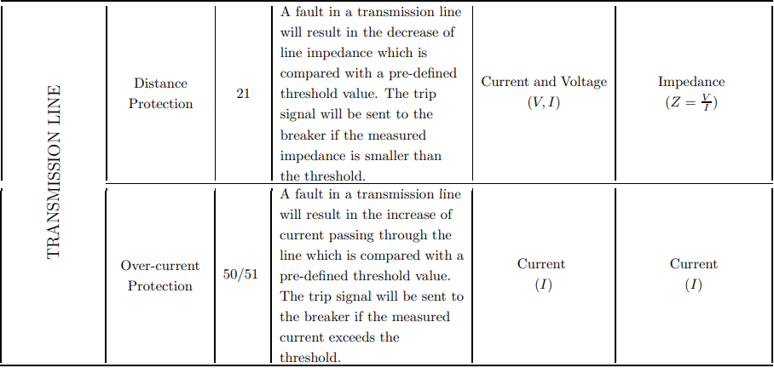

**Figure 11: Principle of Device**

1. **Calculation of Protection Short Circuit Current and Load Current**
   1. **Calculation of maximum short circuit current in operation mode:**

### 

### **Introduction to the short-circuit phenomenon**

A short-circuit is an accidental or intentional low resistance or impedance connection established between two points in an electric circuit that bypasses part of the circuit. The current in an electric circuit flows through the path of least resistance and if an alternate path is created where two points in a circuit are connected with low resistance or impedance then current will flow between the two points through the alternate path. In short circuit conditions the normal level of current flow is suddenly increased by a factor of hundreds or even thousands, which is a deadly magnitude. This flow of high current through the alternate path is known as short circuit current.

The consequences of a short circuit can be disastrous. The consequences are dependent on the capacity of the system to drive short circuit current and the duration it is allowed to flow in a short circuit situation. Locally at the short circuit point there may occur electrical arcs causing damage to insulation, welding of conductors and fire. On the faulty circuit, electro dynamic forces may result in deformation of bus bars and cables and the excessive temperature rise may damage insulation. Other circuits in the network or in nearby networks are also affected by the short-circuit situation. Voltage drops occur in other networks during the time of short circuit and shutdown of a part of a network may include also “healthy” parts of the network depending on the design of the whole network. Electrical installations require protection against short circuit current. The calculation of short-circuit current must be done at each level in the installation in order to determine the important specifications and standards of the equipment and conductors required to withstand or break the short circuit current.

A short-circuit current analysis is probably one of the most crucial calculations of the electrical design process. This analysis allows designers to find the maximum available short circuit current at different points in the electrical system. The short circuit current found is then used to design and specify fault ratings for electrical components that can withstand the tremendous forces of short circuit without harming occupants and without damaging equipment. This calculation can also help identify potential problems and weaknesses in the system and assist in system planning. To calculate the results correctly it is important to know all the parameters of a circuit. Especially in short circuit situations the behavior of the circuits are “strange” and there is no linearity between the voltage of the system and the current flowing

### 

### **Types of short-circuit**

Three-phase electric power is a kind of poly-phase system and it is a method of AC electric power generation, transmission, and distribution. It is the most popular and the most commonly used method by electric power grids worldwide to transfer power. It is also used to power heavy loads and large motors. A three-phase system is normally more economical than an equivalent single-phase system or two-phase system at the same voltage level, since it uses less conductor material to transmit electrical power. The three- phase system was independently invented by Galileo Ferraris, Mikhail Dolivo- Dobrovolsky and Nikola Tesla in the late 1880s.

In a three-phase system various types of short circuit can occur, which may be categorized as shunt faults and series faults. The most occurring types of shunt faults are:

* + - 1. Phase-to-earth (80% of faults): Phase-to-earth is the most occurring fault. This type of fault occurs when one conductor falls to ground or contacts the neutral wire. It could also be the result of trees falling on top of the lines.
      2. Phase-to-phase (15% of faults): Phase-to-phase fault is the result of two conductors being short-circuited. For example: a bird could sit on one line somehow coming in contact with other, or a tree branch could fall on top of two of the power lines.
      3. Phase-to-phase-to-earth: This can be a result of a tree falling on two of the power lines, or other causes.
      4. d)Three-phase (only 5% of initial faults): It is the least occurring fault, this type of fault can only occur by a contact between the three power lines in various forms .
      5. Phase-to-phase-to-phase-to-earth fault: It is also known as the three phase to ground fault.

The primary characteristics of short-circuit currents are:

1. Duration: The current can be self-extinguishing, transient or steady-state.
2. Origin: It may occur due to mechanical reasons (break in a conductor, two conductors coming in contact electrically via a foreign conducting object), internal or atmospheric overvoltage and insulation breakdown due to humidity, heat or a corrosive environment.
3. Location: Inside or outside a machine or an electrical switchboard.

**Short-circuit current**

Voltages generated in the power stations are of sine-wave form, hence, the current flowing through the lines are also of sine-wave form, commonly known as “AC current”. AC currents could be “Symmetrical” or “Asymmetrical” in nature.

ZERO AXIS

**Figure 12: Symmetrical AC current.**

The above figure shows the wave of an AC current which has the same magnitude above and below the zero-axis

When the wave form of the current is symmetrical about the zero-axis it is called “Symmetrical current” and when the wave of the current is not symmetrical about the zero-axis then it is called “Asymmetrical current”.

ZERO AXIS

**Figure 13: Asymmetrical AC current.**

The wave of the current has different magnitude above and below the zero-axis.

ZERO AXIS

**Figure 14: Short-circuit current.**

Short-circuit currents are a mixture of symmetrical and asymmetrical currents, they are asymmetrical during the first few cycles after short-circuit occurs and gradually becomes symmetrical after a few cycles. Oscillation of a typical short-circuit current where the maximum peak occurs during the first cycle of the short-circuit current when the current is asymmetrical, the maximum value of the peak gradually reduces to a constant value as the current becomes symmetrical.

Theoretically, asymmetrical currents are considered to have a DC component and an AC component. The decaying nature of the short-circuit currents are due to the DC component which is usually short lived and disappears in a few cycles. The DC component is produced within the AC system and depends upon the resistances and the reactances of the circuit. The rate of decay is known as “Decrement”.

### Since the short-circuit currents are neither symmetrical nor asymmetrical the available short-circuit current in RMS symmetrical is considered after the DC component becomes zero.

### **Parameters of short-circuit current**

All electrical circuits contain resistance and reactance which are electrically in series and have a combined effect on the entire circuit known as “impedance”.

A simplified model of an AC network can be represented by a source of AC power, switching devices, total impedance *Zk* which represents all the impedances upstream of the switching point and a load, represented by its impedance (see Fig.). In a real network the total impedance *Zk* is made up of the impedances of all components upstream of the short circuit. The general components are generators, transformers, transmission lines, circuit-breakers and metering systems.

If a connection with negligible impedance occurs between point A and point B of a circuit, it results in a short circuit current *Ik* limited only by the impedance *Zk*. The Short- circuit current *Ik* develops under transient conditions depending on the relation between the reactance *X* and the total resistance *R* that make up the impedance *Z*.

If the circuit is mostly resistive the waveform of the current is following the waveform of the voltage but if there are inductances in the circuit the waveform of the current will differ from the waveform of the voltage during a transient time of the process. In an inductive circuit the current cannot begin with any value but zero. The influence of inductances is described by reactance *X* in AC circuits with a fixed frequency of the voltage. In low voltage systems where cables and conductors represent most of the impedance it can be regarded as mostly resistive. In power distribution networks the reactance is normally much greater than the resistances. The total magnitude of impedance *Zk* is calculated using Equation .

Zk = JR2 + X2

k k

*Rk* is the total resistance in ohms and *Xk* is the total reactance in ohms.

*Uf*



*Zk*

A

R

X

Load

B

**Figure 15: Simplified network diagram**

In the simplified circuit above the voltage is constant and so is the total impedance. In power distribution networks, reactance *X* is usually greater than resistance *R* and the ratio of *R* / *X* is between 0.1 and 0.3. This ratio is virtually equal to cos φ for low values. The characteristics of all the various elements in the fault loop must be known.

R

Cos ɔ =

√R2 + X2

The above equation seems simple, but in practice it is very difficult to accurately calculate the impedance *Zk*. A variety of voltage sources (power stations, synchronous motors, etc) are connected to a large shared network through a variety of lines and transformers.

Equation 2

## **Calculation Method**

### **Introduction**

Calculation of the short-circuit current involves the representation of the entire power system impedances from the point of the short-circuit back to and including the source(s) of the short-circuit current. The value of the impedance depends on the short-circuit ratings for the devices or equipment under consideration.

After all the components in the fault loop is represented with their corresponding impedance, the actual short-circuit computation is very simple. The standards propose a number of methods. Application guide C 15-105, which supplements NF C 15-100 (Normes Françaises) (low-voltage AC installations), details three methods.

1. **The Impedance Method**
2. **The Composition Method**
3. **The Conventional Method**

For the purpose of this study only the first two Methods are considered.

### **Theory for calculating short-circuit current using the impedance method**

The “impedance method”, reserved primarily for low-voltage networks, it was selected for its ability to calculate the short-circuit current at any point in an installation with a high degree of accuracy, given that virtually all characteristics of the circuit are taken into account.

The main objective is to calculate the short-circuit current and to provide the correct protective equipment designed to isolate the faulted zone in the appropriate time. The basic process of a fault current analysis is summing each component (transformers and conductors) together, from (and including) the source to the fault point to get the total impedance at a particular point along the path. In order to sum these impedances, the individual resistances and reactances of all the various components must first be summed.

In order to perform a fault current analysis, some information must be obtained from the utility, manufacturers and the designers. The three phase short-circuit current *Ik* can be calculated by applying Ohm’s law.

where *Zk* = resulting impedance per phase from the voltage source to the fault point and

*Uf* = phase voltage of the voltage source.

*Uf* and *Zk* can be regarded to be the Thevenin voltage and Thevenin impedance per phase in the three phase net seen from the fault point. *Ik* can be regarded as the short current source in the equivalent per phase Norton circuit.

In order to perform a fault current analysis, all the characteristics of the different elements in the fault loop must be known. These information's are provided by the utility, manufacturers and the designers.

The information's needed to perform this process are as follows:

1. Utility ratings.
2. Transformer ratings.
3. Transmission cable information (e.g. Length, Type, Area).

Equation 2-3 implies that all impedances are calculated with respect to the voltage at the fault location, this leads to complications that can produce errors in calculations for systems with two or more voltage levels.

It means that all the resistances and the reactances of all the components on the high voltage

side of the line must be multiplied by the square of the reciprocal of the transformation ratio while calculating a fault on the low voltage side of the transformer.

#### Transmission Lines

The resistance and the reactance of the cables are generally expressed in terms of ohms- per-phase per unit length. For high-voltage (above 600 volts) cables the resistance becomes so small that it is normally omitted and only the reactance of the cables are estimated to be equal to the impedance of the cables. If the lengths of the cables are less than 1000 feet then the entire impedance can be omitted with negligible error.

The Resistance of transmission line is

l(kn) RL = q · A(nn2)

ohn

For copper wire q = 1.7 · 10–8 fi m and for aluminum wire q = 2.6 · 10–8 fi m . The reactance of transmission line is

XL = l · k Equation 3

***k* = 0.4 (For copper wire).**

### **Theory of calculating short-circuit current using the “composition method”**

The “composition method” is used when the characteristics of the power supply are not known. The upstream impedance of the given circuit is calculated on the basis of an estimate of the short-circuit current at its origin. Power factor cos φ = *R* / *X* is assumed to be identical at the origin of the circuit and the fault location. In other words, it is assumed that the elementary impedances of two successive sections in the installation are sufficiently similar in their characteristics to justify the replacement of vector addition of the impedances by algebraic addition. This approximation may be used to calculate the value of the short-circuit current modulus with sufficient accuracy for the addition of a circuit.

The short-circuit power is the maximum power that the network can provide to an installation during a fault. It depends directly on the network configuration and the

impedance of its components through which the short-circuit current passes. With short- circuit power *Sk*, in a fault point (or an assumed fault point) we mean:

Sk = √3 ·U · Ik Equation 4

where *U* = normal line voltage before the short-circuit occurs and *Ik* = the short-circuit current when the fault has occurred. This means of expressing the short-circuit power implies that *Sk* is invariable at a given point in the system regardless of the voltage. The advantage with this concept is that it is a mathematical quantity that makes the calculation of short-circuit currents easier.

The part short-circuit power is defined as the short-circuit power that is developed in a device according to Equation 2-10 if the device is fed by an infinite powerful net (that is a generator with internal impedance = 0) with line voltage *U*, if we get a short-circuit at the terminals of the device.

Devices mean both active devices that can deliver power, and passive devices. A transformer and a transmission line are examples of passive devices. They can deliver power only if they are connected to a feeding net where there are generators.

Combining Equation 3 and Equation 4 gives:

Sk = U2/Zk

Equation 5

Equation 5 can calculate the part short-circuit power for a device if the impedance *Zk*

is known or its impedance can be calculated if the part short-circuit power is known.

The process of using the "composition method" method is very similar to the “impedance method”, here the vector quantity of the short-circuit power for each component in the system are calculated separately and added together (including the total apparent power of the net *Skn* ) to calculate the total short-circuit power *Sk*.

Consider the system below:

T1

P

A

B

*U*

L

1

L

2

C

T2

T3

**Skn =1000MVA**

*Cosφ = 0.15*

**Figure 16: Schematic diagram of a simple transmission system.**

The vector representation of the total short-circuit power at point P is:

S˙kN = P + jQ

Where P = SkN · Cos߮ and Q = SkN · Sin߮

The total short-circuit power at point A is:

1 1 1

= +

S˙ S˙ S˙

kÆ kN kL1

The total short-circuit power of the two parallel transformers T1 and T2 is:

S˙kT = S˙kT1 + S˙kT2

The total short-circuit power at point B is:

1

=

S˙kB

1

+

S˙kÆ

1

S˙kT

Similarly, the total short-circuit power at the point of the short-circuit is calculated if there are more components in the circuit.

Another technique is the vector addition of the impedances of all the components, instead of the vector summation of the short-circuit power of each component. Then Equation 2-11 is used to calculate the total short-circuit power which is then substituted in Equation 2-10 to calculate the total short-circuit current of the circuit.

The complex form of the impedance is expressed as *Z = R + jX*. Where, *R* is the resistance of the component and *X* is the reactance of the component.

* 1. **Software Analysis:**

**Input Diagram on MATLAB:**

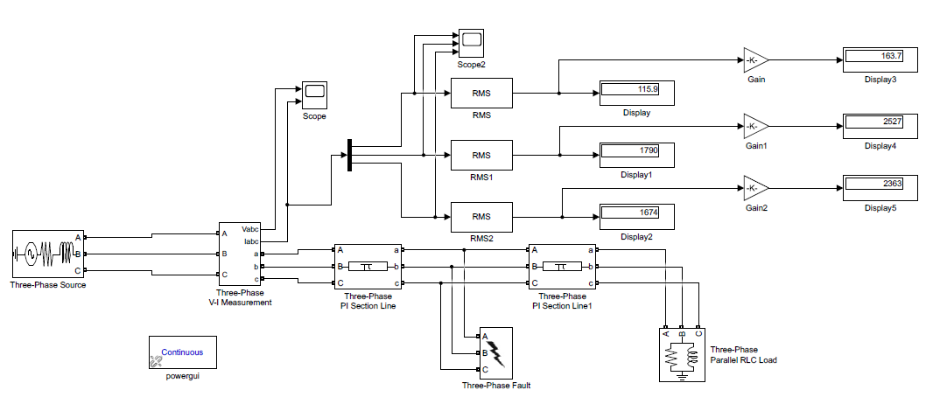

**Figure 17: Input on MATLAB**

**Input Waveform:**

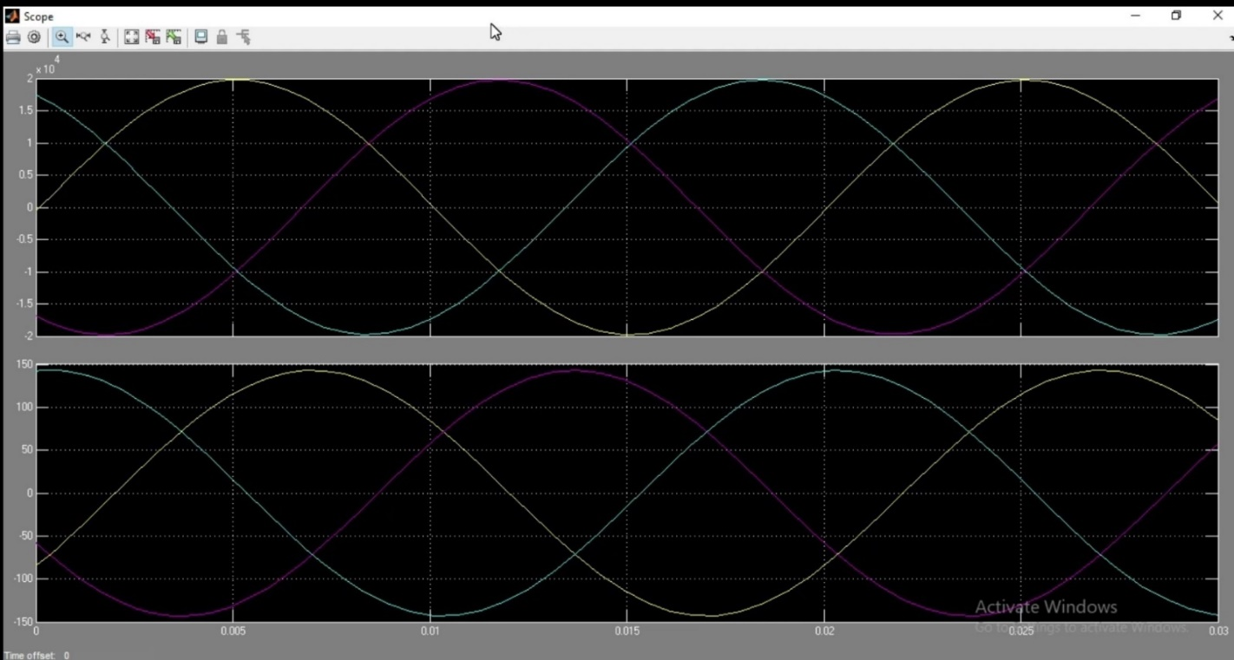

**Figure 18: Input Waveform**

**Fault at Phase-A:**

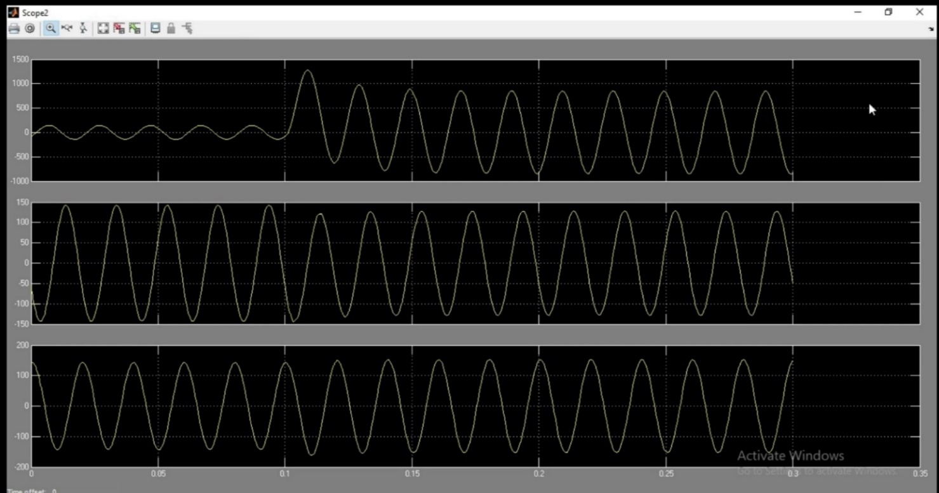

**Figure 19: Fault at Phase-A**

**Fault at Phase-A & Phase-B:**

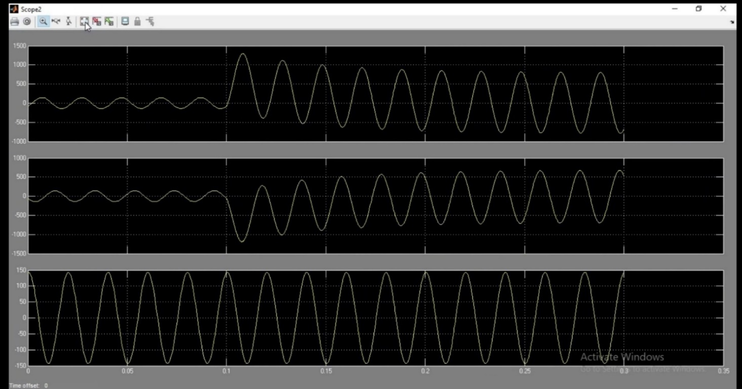

**Figure 20: Fault at Phase-B**

**Fault at Phase-A, Phase-B & Phase-C:**

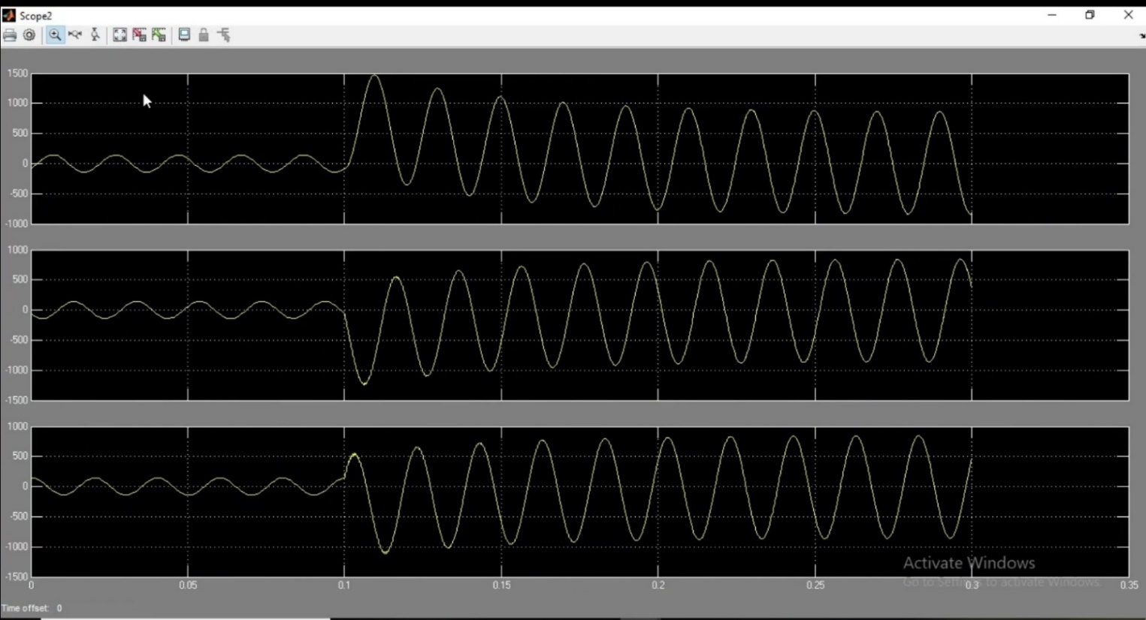

**Figure 21: Fault at Phase-A, Phase-B & Phase-C**

* 1. **Maximum Load Current Calculation:**

**Using ETAP Software:**

**Input System:**

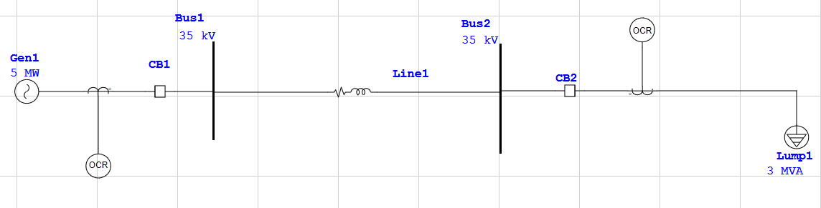

**Figure 22: Input System on ETAP**

**Input Parameters:**

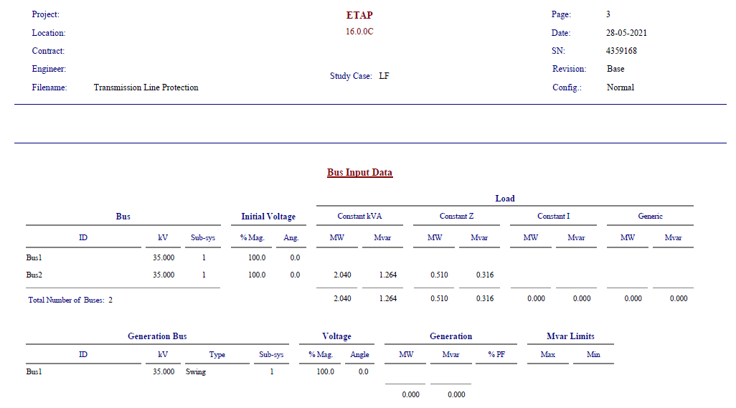

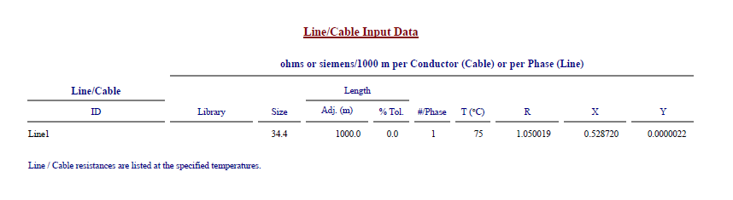

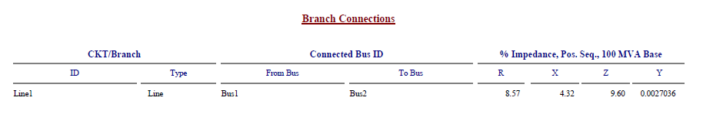

**Figure 23: Input Parameters**

**Output:**

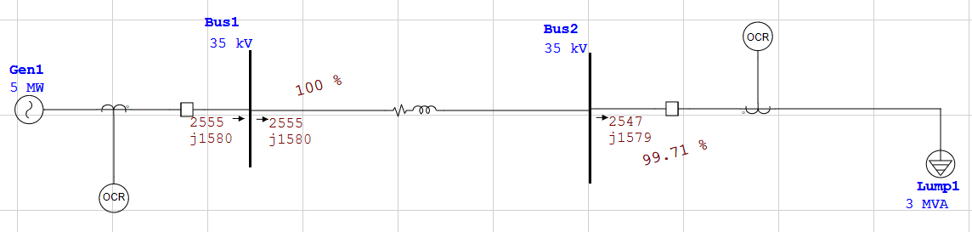

**Figure 24: Active & Reactive Power Flow**

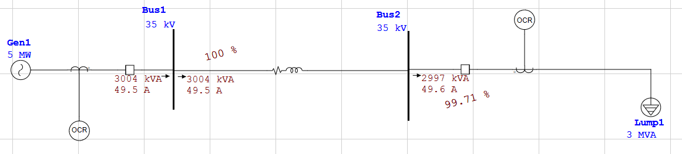

**Figure 25: Maximum Load Current & Apparent Power**

**Report:**

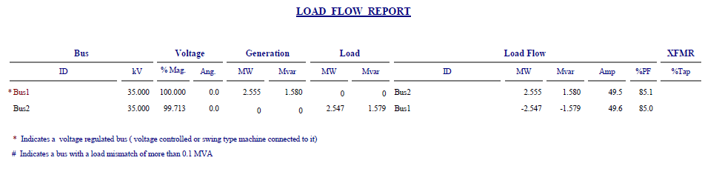

**Figure 26: Load Flow/Maximum Current Report**

1. **35kV Line Protection Setting Calculation**

We began the Circuit in ETAP by adding every of the parts which is mentioned above to the ETAP “Edit Mode” and connected them to obtain the Required Diagram. We entered the details of each component as needed by the recently referenced Table. Thus, We obtain Full Circuit Diagram.

* 1. **Input Circuit:**



**Figure 27: Input system on ETAP**

For Protecting our components we have to set Relays. For setting Relays we need to configure Current Transformer (CT). For CT we need CT Ratio as an Input Value for CT. For Turn Ratio of CT we need Maximum Load Current Flowing through each component. So, To get this data Firstly we did a Load Flow Analysis of this Power System. It brought about showing the current and the power of each branch in the diagram.



**Figure 28: Load Flow Analysis Report**

***Conclusion Obtained From Load Flow Analysis,***

|  |  |  |
| --- | --- | --- |
| **Component** | **Maximum Load Current (A)** | **Apparent Power (kVA)** |
| **Generator (Gen1)** | **49.5** | **3004** |
| **35-kV Transmission Line** | **49.5** | **3004** |
| **Lump Load (Lump1)** | **49.6** | **2997** |

For Turn Ratio of CT we also need the Fault Current Flowing through each component. So, to get fault currents we did a Short Circuit Analysis of this Power System. It brought about showing the Fault Current of each branch in the diagram.

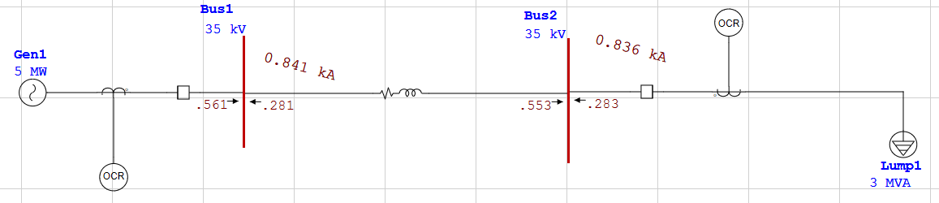

**Figure 29: Short Circuit Analysis**

Now we need to choose the CT ratios and relays properly to trip the circuit Breaker Properly. Below Table shows the Standard CT Ratios.

Then we have to choose nearest CT Ratio from the Below Table.

|  |  |  |
| --- | --- | --- |
| **Sr. No.** | **Manufacturer’s Maximum Production** | **Standard Values** |
| **1** | 600:5 | 50:5, 100:5, 150:5, 200:5, 250:5, 300:5, 400:5, 450:5, 500:5, 600:5 |
| **2** | 1200:5 | 100:5, 200:5, 300:5, 400:5, 500:5, 600:5, 800:5, 900:5, 1000:5, 1200:5 |
| **3** | 2000:5 | 300:5, 400:5, 500:5, 800:5, 1100:5, 1200:5, 1500:5, 1600:5, 2000:5 |
| **4** | 3000:5 | 300:5, 500:5, 800:5, 1000:5, 1200:5, 1500:5, 2000:5, 2200:5, 2500:5, 3000:5 |
| **5** | 4000:5 | 500:5, 1000:5, 1500:5, 2000:5, 2500:5, 3000:5, 3500:5, 4000:5 |
| **6** | 5000:5 | 500:5, 1000:5, 1500:5, 2000:5, 2500:5, 3000:5, 3500:5, 4000:5, 5000:5 |

With the reference from Table of Standard CT Values and Maximum Load Current **IMAX-LOAD** (which we get after Load Flow Analysis). To increase the relay’s Protection Capability, we will always choose values that are closer to the **IMAX-LOAD**.

|  |  |  |  |
| --- | --- | --- | --- |
| **Sr. No.** | **Component** | **IMAX-LOAD (A)** | **CT Ratio** |
| **1** | Generator (Gen1) | 49.5 | 50:5 |
| **2** | 35-kV Transmission line | 49.5 | 50:5 |
| **3** | Lumped Load (Lump1) | 49.6 | 50:5 |

Now it’s time to select Relay Model from ETAP Library & to Calculate IPickup For Each Component, From IPickup we get Pickup Value.

To calculate Ipickup we use the following relation,

**2 x IMax-Load < IPickup < 1/3 x IMax-Fault**

**For Generator:**

As IPickup,

2 x IMax-Load < IPickup

2 x 49.5 < IPickup

99 < IPickup

**For Transmission Line:**

2 x 49.5 < IPickup

99 < IPickup

**For Lumped Load:**

2 x 49.6 < IPickup

99.2 < IPickup

In ETAP, if we enter Pickup value in relay settings then it automatically IPickup. So, we randomly entered some values for Pickup to get Desired IPickup for every component. By this Process we got Pickup value for Every Component. So, we make following Table. The specifications of relays also showed in Table.

|  |  |  |  |  |  |  |  |
| --- | --- | --- | --- | --- | --- | --- | --- |
| **Sr. No.** | **Component** | **Relay ID** | **Relay Model** | **Protection Type** | **IPickup** | **Pickup value** | **Relay Output** |
| **1** | Generator | Relay1 | Schneider Electric P521 | Over-Current, Differential &Over-Load | 99< | 2 | Open CB1 |
| **2** | Transmission Line | Relay1 | Schneider Electric P521 | Over-Current, Differential &Over-Load | 99< | 2 | Open CB1 |
| **3** | Lumped Load | Relay2 | Schneider Electric P521 | Over-Current, Differential &Over-Load | 99.2< | 2 | Open CB2 |

**Fault at BUS-1:**

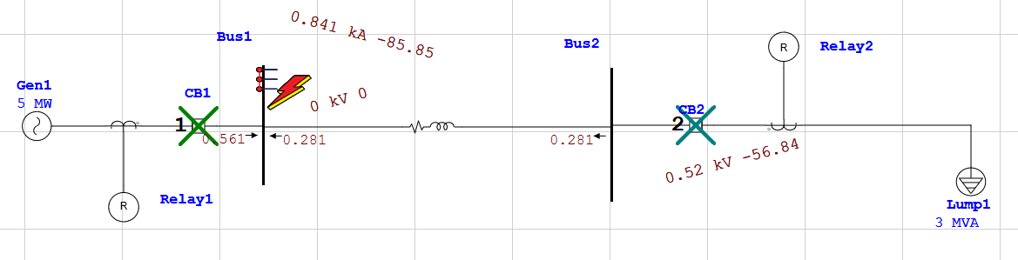

**Figure 30: Fault at Bus 1**

**Relay Sequence of Operation:**

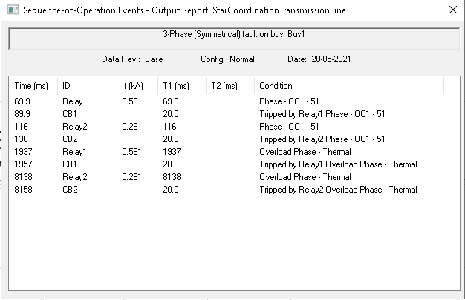

**Figure 31: Relay Sequence of operation**

**Fault at BUS-2:**

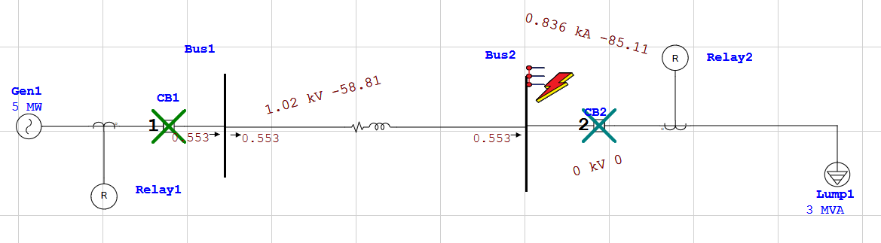

**Figure 32: Fault at Bus 2**

**Relay Sequence of Operation:**

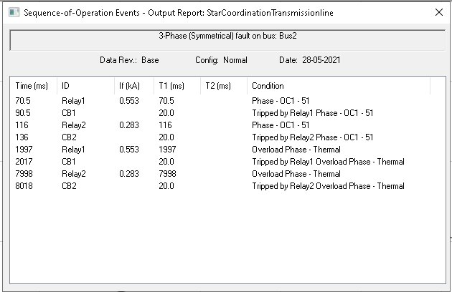

**Figure 33: Relay Sequence of operation**

1. **35kV Line Protection Order**

**Transmission line protection**

The excessive currents accompanying a fault, are the basis of overcurrent protection schemes. For transmission line protection in interconnected systems, it is necessary to provide the desired selectivity such that relay operation results in the least service interruption while isolating the fault.

**Three Methods of Relay Grading**

1. **Time Grading**
2. **Current Grading**
3. **Inverse-Time Overcurrent Relaying**
4. **Time Grading**

Time grading ensures that the breaker nearest to the fault opens first, by choosing an appropriate time setting for each of the relays. The time settings increase as the relay gets closer to the source. A simple radial system shown in Figure demonstrates this principle.

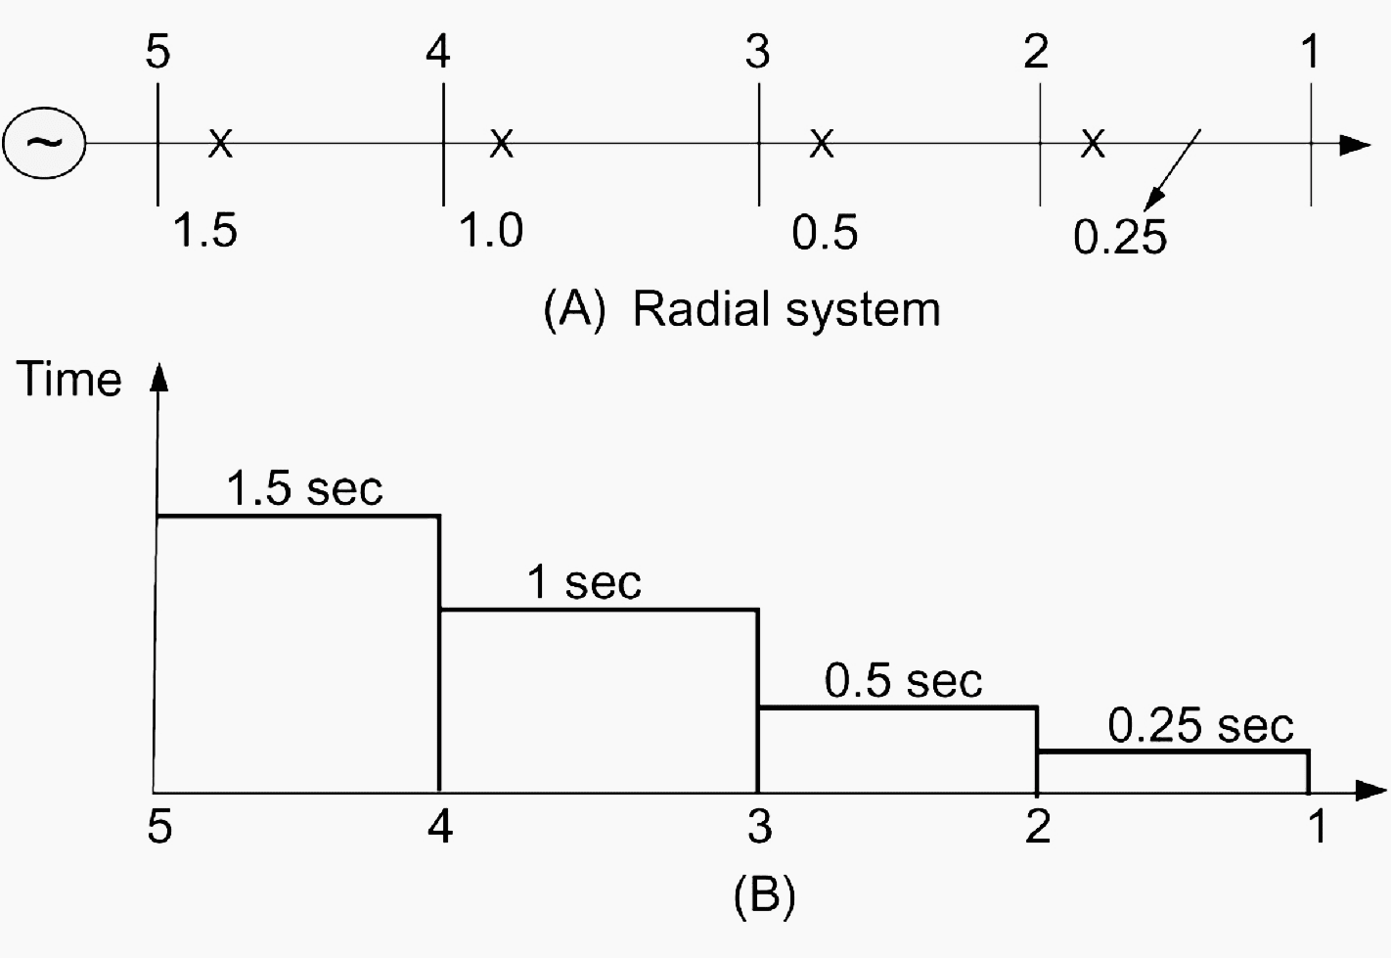

**Figure 34: Time Grading**

A protection unit comprising a definite time-delay overcurrent relay is placed at each of the points 2, 3, 4, and 5. The time-delay of the relay provides the means for selectivity. The relay at circuit breaker 2 is set at the shortest possible time necessary for the breaker to operate (typically 0.25 second).

The relay setting at 3 is chosen here as 0.5 second, that of the relay at 4 at 1 second, and so on. In the event of a fault at F, the relay at 2 will operate and the fault will be isolated before the relays at 3, 4, and 5 have sufficient time to operate.

1. **Current Grading**

Fault currents are higher the closer the fault is to the source and this is utilized in the current-grading method. Relays are set to operate at a suitably graded current setting that decreases as the distance from the source is increased.

Figure shows an example of a radial system with current grading. The advantages and disadvantages of current grading are best illustrated by way of examples.

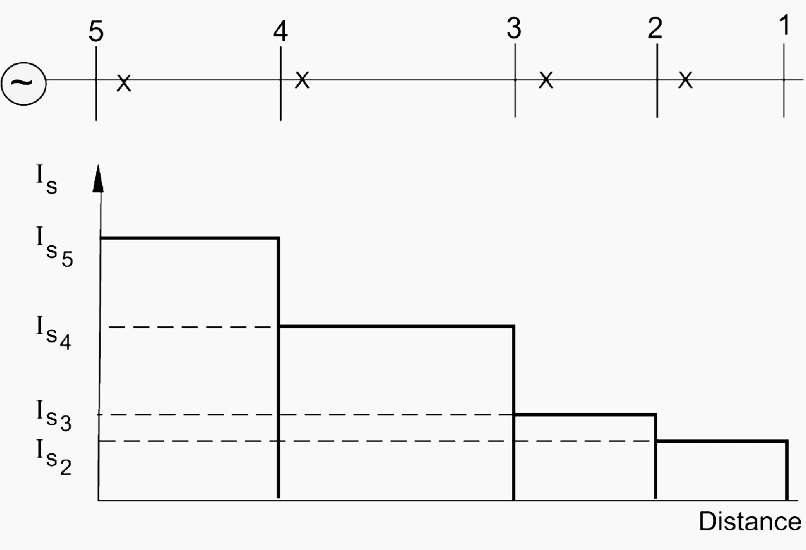

**Figure 35: Current Grading**

1. **Inverse-Time Overcurrent Relaying**

The inverse-time overcurrent relay method evolved because of the limitations imposed by the use of either current or time alone. With this method, the time of operation is inversely proportional to the fault current level, and the actual characteristics are a function of both time and current settings.

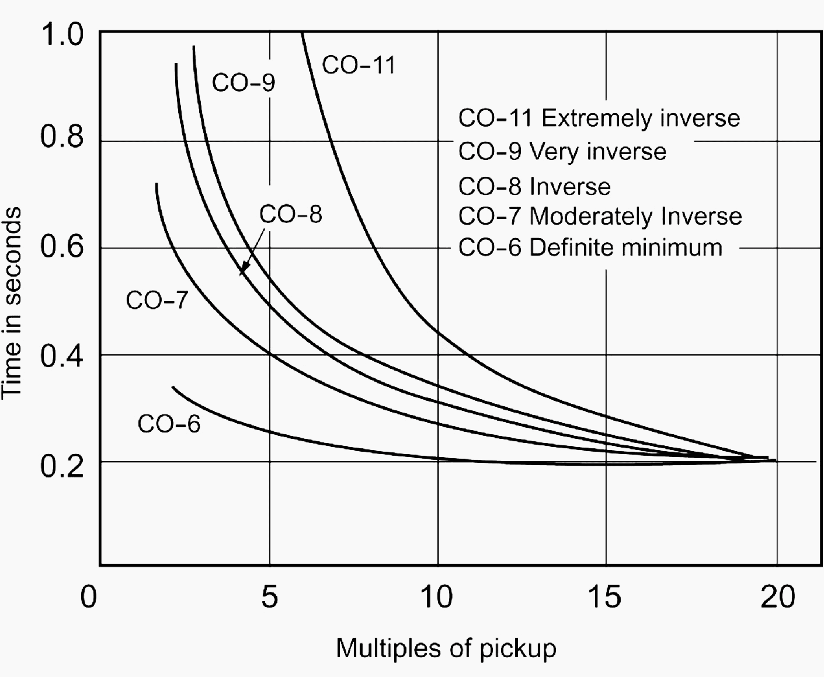

**Figure 36: Multiples of Pickup**

Relay type CO-7 is in common use. Figure shows a radial system with time-graded inverse relays applied at breakers 1, 2, and 3. For faults close to the relaying points, the inverse-time overcurrent method can achieve appreciable reductions in fault-clearing times.

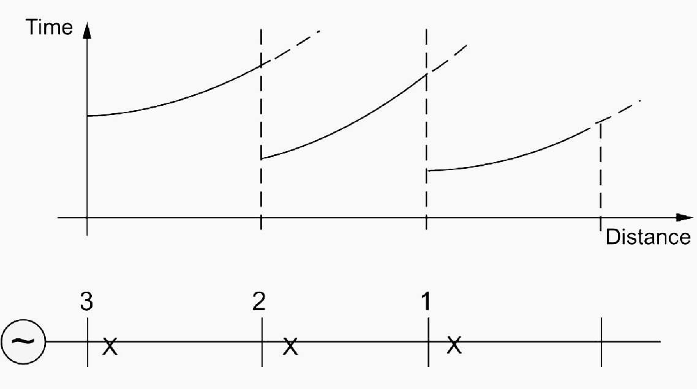

**Figure 37: Velocity Break Protection**

The operating time of the time-overcurrent relay varies with the current magnitude. There are two settings for this type of relay:

Pickup current is determined by adjusted current coil taps or current tap settings (C.T.S.). The pickup current is the current that causes the relay to operate and close the contacts.

Time dial refers to the reset position of the moving contact, and it varies the time of operation at a given tap setting and current magnitude.

The time characteristics are plotted in terms of time versus multiples of current tap (pickup) settings, for a given time dial position.

There are five different curve shapes referred to by the manufacturer:

**CO-11 Extreme inverse**

**CO-9 Very inverse**

**CO-8 Inverse**

**CO-7 Moderately inverse**

**CO-6 Definite minimum**

**These shapes are given in Figure 3 above.**

**Example with 35 kV radial system**

**Consider the 35 kV radial system shown in Figure 5. Assume that all loads have the same power factor. Determine relay settings to protect the system assuming relay type CO-7 (with characteristics shown in Figure 6) is used:**

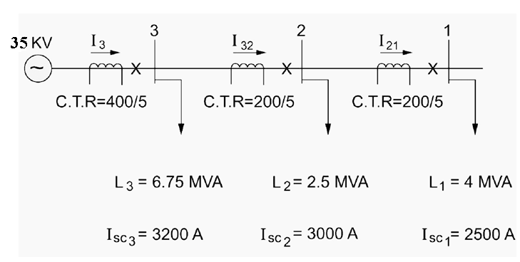

**Figure 38: 35-kV Radial System**

**Solution:**

**The normal currents through the sections are calculated as:**

**With the current transformer ratios given, the normal relay currents are:**

We can now obtain the current tap settings (C.T.S.) or pickup current in such a manner that the relay does not trip under normal currents. For this type of relay, the current tap settings available are 4, 5, 6, 7, 8, 10, and 12 amperes.

For Position 1, the Normal current in the relay is 1.6495A. Thus, we choose:

**(C.T.S.)1 = 4A**

For Position 2, the Normal current in the relay is 2.6805A. Thus, we choose:

**(C.T.S.)2 = 4A**

For Position 3, the Normal current in the relay is 5.46425A. Thus, we choose:

**(C.T.S.)3 = 6A**

Observe that we have chosen the nearest setting higher than the normal current.

The next task is to select the intentional delay indicated by the time dial setting (T.D.S.). We utilize the short circuit currents calculated to coordinate the relays. The current in the relay at 1 on a short circuit at 1 is:

Expressed as a multiple of the pickup or C.T.S. value, we have:

We choose the lowest T.D.S. for this relay for fastest action. Thus:

(T.D.S)1 =

By reference to the relay characteristic, we get the operating time for relay 1 for a fault at 1 as:

To set the relay at 2 responding to a fault at 1, we allow 0.1 second for breaker operation and an error margin of 0.3 second in addition to . Thus,

The short circuit for a fault at 1 as a multiple of the C.T.S. at 2 is:

From the characteristics for 0.55-second operating time and 15.625 ratio, we get

**(T.D.S.)2 2**

The final steps involve setting the relay at 3. For a fault at bus 2, the short circuit current is 3000 A, for which relay 2 responds in a time obtained as follows:

For the (T.D.S.)2= 2, we get from the relay’s characteristic,

T22 = 0.50s

Thus, allowing the same margin for relay 3 to respond to a fault at 2, as for relay 2 responding to a fault at 1, we have:

T32 = T22 + 0.1 + 0.3 = 0.90s

The current in the relay expressed as a multiple of pickup is:

Thus, for T3 = 0.90, and the above ratio, we get from the relay’s characteristic,

**(T.D.S.)3 2.5**

We note here that our calculations did not account for load starting currents that can be as high as five to seven times rated values. In practice, this should be accounted for.